**1.Create user table with username, roll number, email, password**

**

**CREATE TABLE:**

**CREATE TABLE Student (Username varchar (20), email varchar (20), roll number int(15),password varchar(30));**

**INSERT QUERY:**

**Insert into Student values (‘uv’, ‘uv@gmail.com’,’3’,’04’);**

**Insert into Student values (‘AB’, ‘AB@gmail.com’,’2’,’03’);**

**Insert into Student values (‘CD’, ‘CD@gmail.com’,’8’,’05’);**

**Insert into Student values (‘MN’, ‘MN@gmail.com’,’0’,’09’);**

**2.perform UPDATE DELETE queries with user table?**

**QUERY:**

**UPDATE:**

**Update Student set password=00 where username =’CD’;**

**DELETE:**

**Delete from user where roll no =’4’;**

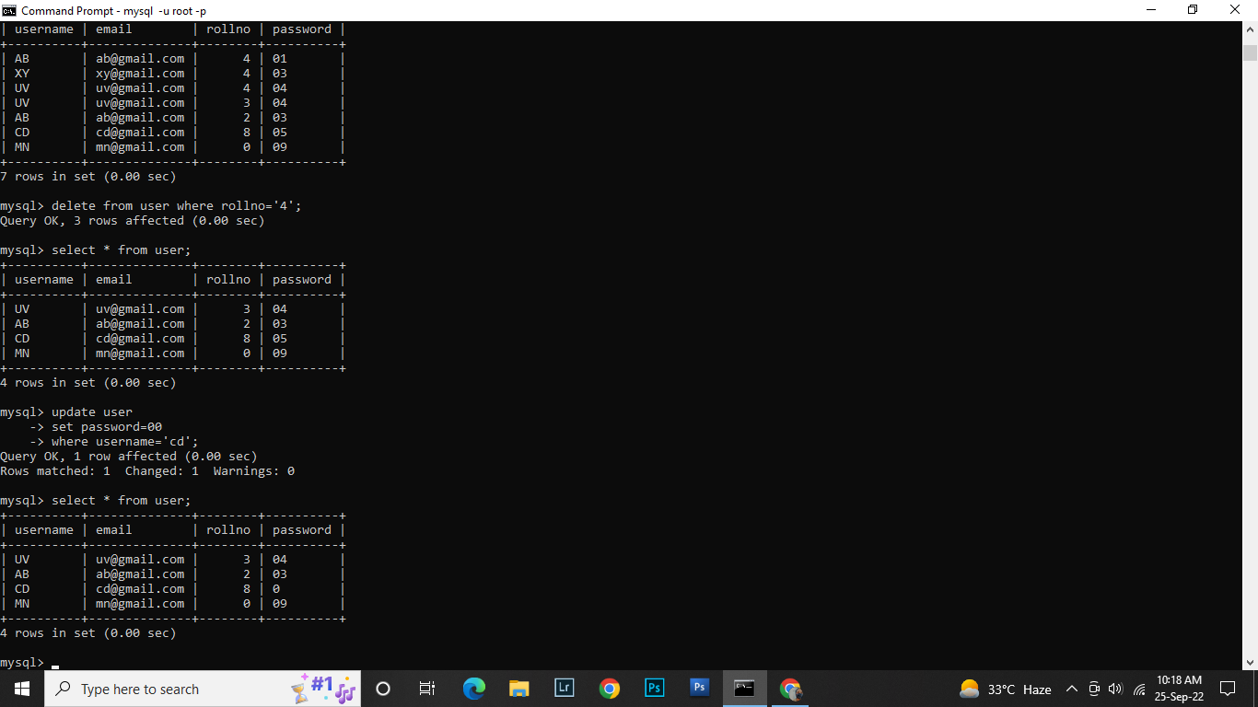

**3.Connect Python code to db2?**

import ibm db

conn =ibm_db.connect("DATABASE=bludb; HOSTNAME=2d46b6b4-cbf6-40eb-bbce-6251e6ba0300.bs2 1090108kqblod81cg.databases.appdomain.cloud; PORT=32328; SECURITY=SSL; SSLServerCer tificate-DigiCertGlobal RootCA.crt; UID=gmz37043; PWD-5eCfk6Y0pNcZhK1H", ,)

print(conn)

print("connection successful...")